3.3 Daily Schedule
Circle Time

Center Time
Clean-up  Wash hands | 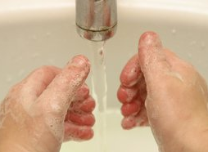

Lunch
Story Time
Small Group Activities

Outside Play
Gross Motor
Snack Time

Dismissal | 

